**QUESTIONS**

**Ques-1:** Enumerate and differentiate different Load balancers in AWS?

**Ans:** In AWS, there are several load balancers available, including:

1. **Application Load Balancer (ALB):** This load balancer is designed to distribute traffic to multiple target groups based on application-level information, such as HTTP headers, URLs, and application cookies. It is ideal for web applications and supports HTTP, HTTPS, and WebSocket protocols.
2. **Network Load Balancer (NLB):** This load balancer is designed to handle high volumes of traffic and distribute it to targets based on IP address, protocol, and port. It is ideal for non-HTTP(S) traffic, such as TCP, UDP, and TLS.
3. **Classic Load Balancer (CLB):** This load balancer is the oldest and most basic of the three types. It distributes traffic to multiple EC2 instances based on the IP address and port number. It is suitable for applications that require simple load balancing.

Some differences between these load balancers include:

* ALB supports HTTP, HTTPS, and WebSocket protocols, while NLB supports TCP, UDP, and TLS.
* ALB uses content-based routing to distribute traffic to target groups based on application-level information, while NLB distributes traffic based on IP address, protocol, and port.
* ALB provides advanced features like path-based routing, host-based routing, and redirects, while NLB does not support these features.
* Classic Load Balancer (CLB) is the oldest and simplest of the three types, and it distributes traffic based on IP address and port. CLB has been deprecated by AWS, and it is recommended to use ALB or NLB instead.

**Ques-2:** Explain :

1. **Load Balancer-** A load balancer is a service that distributes incoming network traffic across multiple targets, such as EC2 instances, containers, or IP addresses. Its primary purpose is to improve the availability and scalability of applications by evenly distributing traffic to these targets, thereby preventing any one target from becoming overwhelmed with requests. Load balancers in AWS can be managed and configured dynamically, and they can be integrated with other AWS services.
2. **Target Group-** A target group is a logical group of targets that a load balancer routes traffic to. It can include one or more targets, such as EC2 instances or IP addresses. When a load balancer receives incoming traffic, it forwards the traffic to the appropriate target group based on the rules defined by the listener. Target groups can be configured with health checks to ensure that only healthy targets receive traffic.
3. **Rules-** Rules are used by a load balancer to determine which target group to route incoming traffic to. Each rule is associated with a listener and specifies the conditions that must be met for the rule to be applied. For example, a rule might specify that incoming traffic should be routed to a target group if the traffic is received on a specific port, or if the traffic contains a specific HTTP header.
4. **Listeners**- A listener is a process that checks for connection requests from clients, and forwards those requests to the appropriate target group based on the rules defined for that listener. A load balancer can have multiple listeners, each associated with a different port and protocol. For example, a load balancer might have an HTTP listener associated with port 80, and an HTTPS listener associated with port 443.
5. **Load scheduling algorithms**- Load scheduling algorithms are used by load balancers to determine how incoming traffic should be distributed among the targets in a target group. Some commonly used load scheduling algorithms include:
6. **Round Robin:** Each target in the target group is used in turn, with traffic distributed evenly across all targets.
7. **Least Connections:** Traffic is routed to the target with the fewest active connections, in order to balance the load more evenly.
8. **IP Hash:** Traffic is distributed based on a hash of the client's IP address, ensuring that the same client is always routed to the same target.
9. **Weighted:** Traffic is distributed based on the weighting assigned to each target, allowing more traffic to be routed to more powerful targets.

**EXPERIMENT-4: Show how to use Application Load Balancer in AWS**

**Step-1:** Login to AWS console and go to EC2 dashboard.

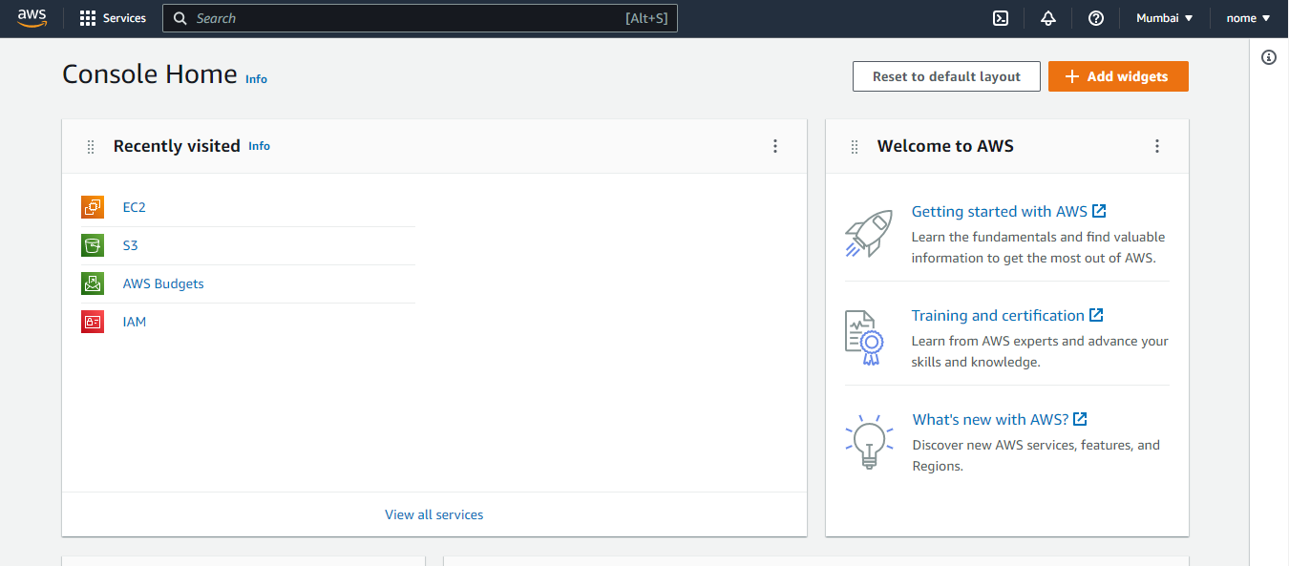

**Step-2:** Now go to instances.

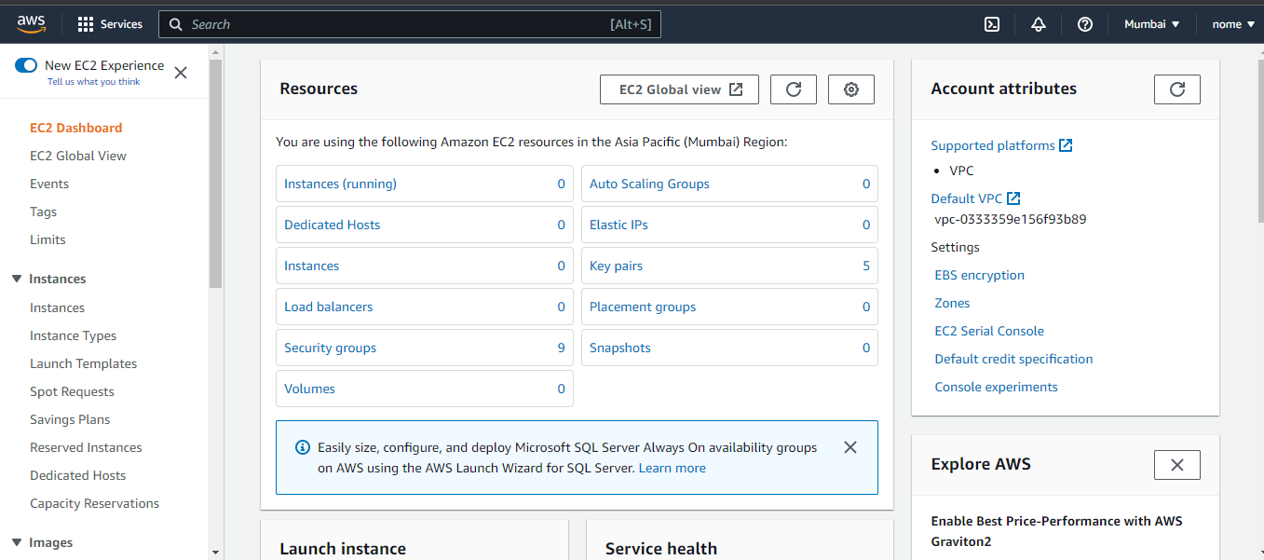

**Step-3:** Now we have to make 2 linux instances. Click on Launch Instances.

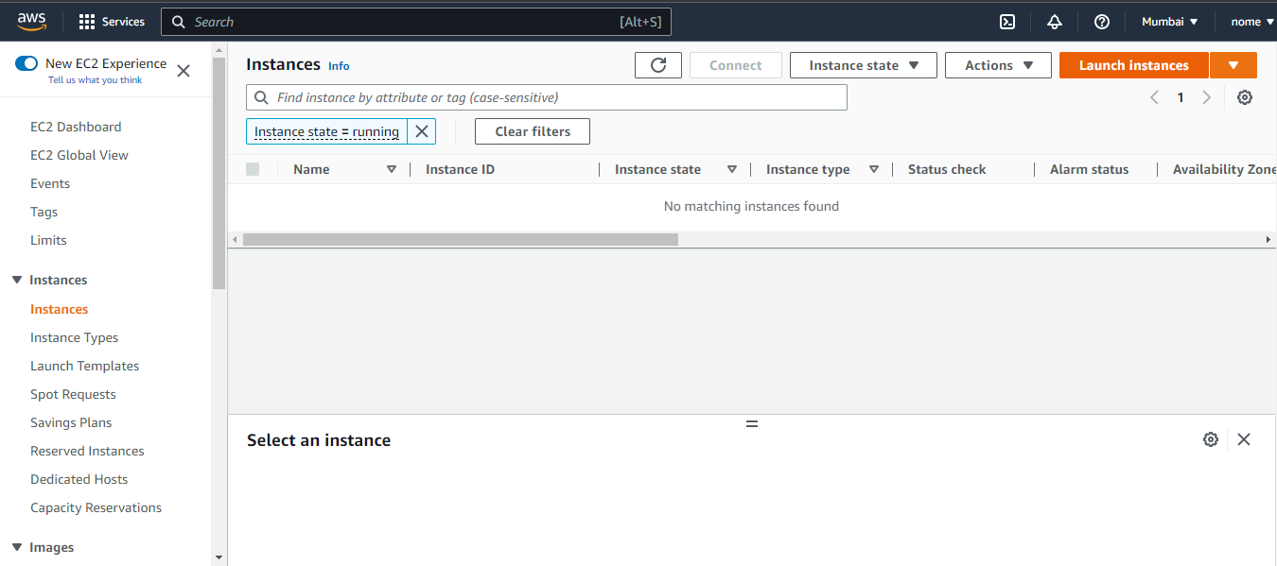

**Step-4:** Name the linux instance and choose the AMI.

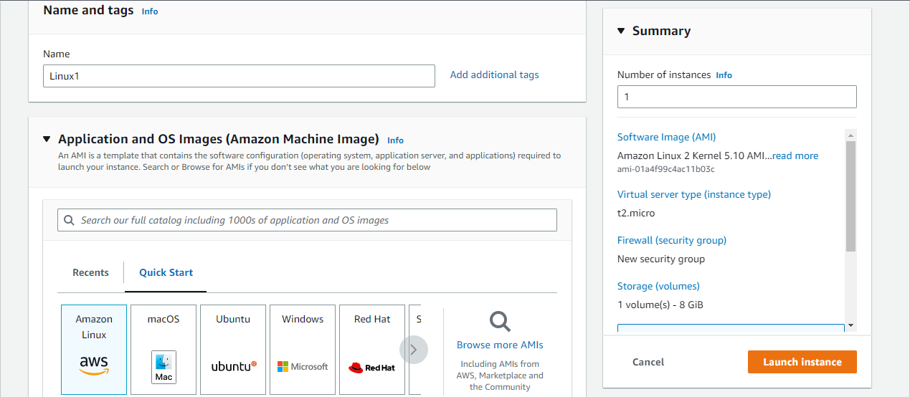

**Step-5:** Choose the instance type ‘t2.micro’ and the key pair or make a new key pair.

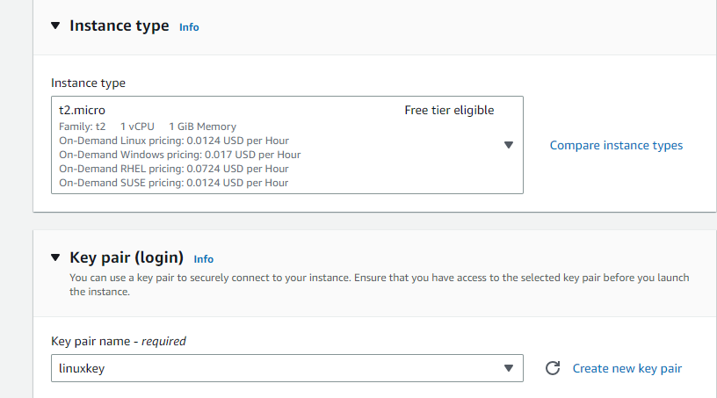

**Step-6:** Now choose the security groups.

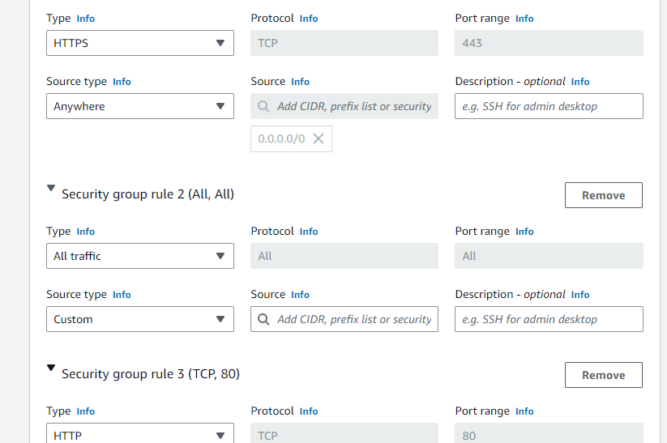

**Step-7:** Now go to advanced details and go to user data. Paste the script in the space provided and choose the number of instances to 2.

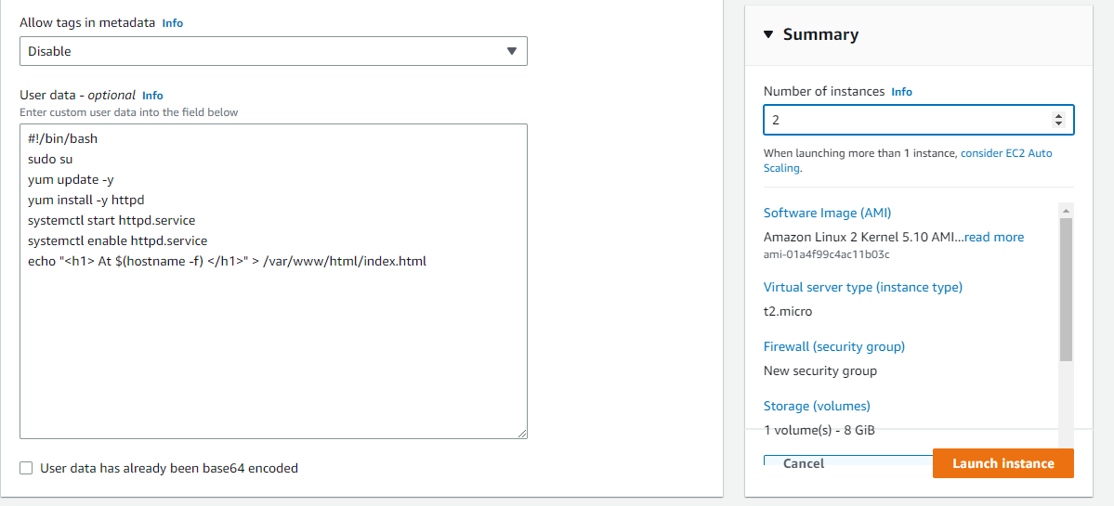

**Step-8:** Instances have been successfully created with the same name. Change the name of the other instance.

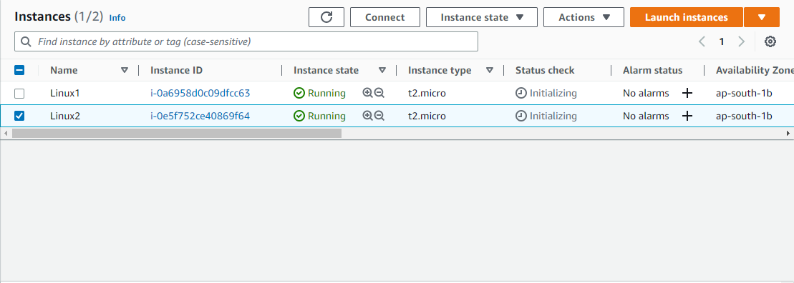

**Step-9:** Now we will group the two instances. Go to load balancing and select ‘Target Groups’. Click on create target group.

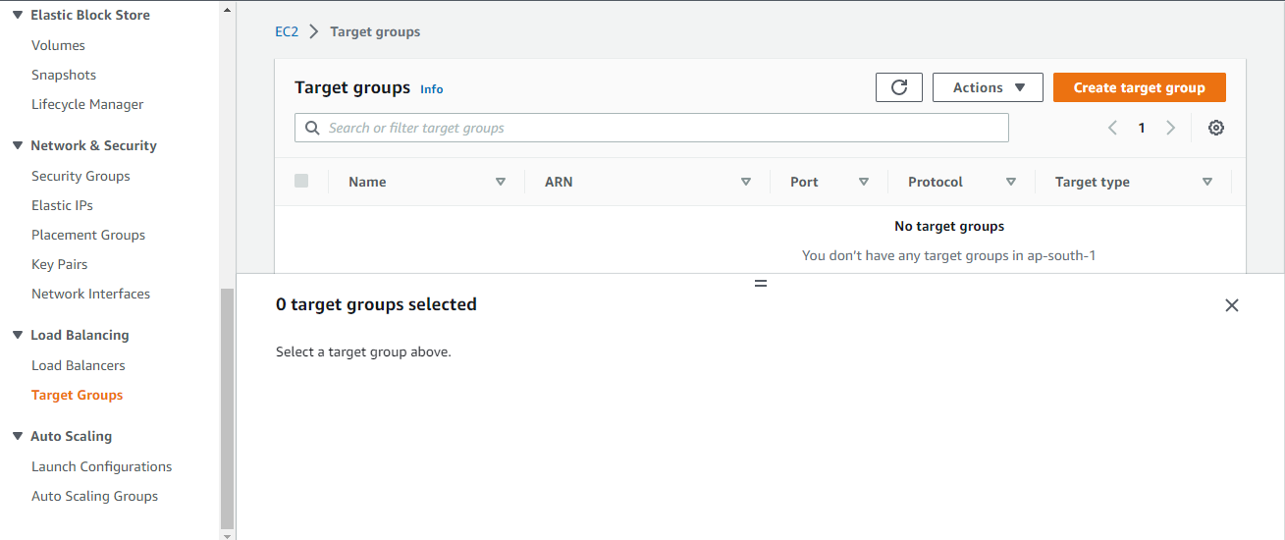

**Step-10:** Specify the group details; choose the target type.

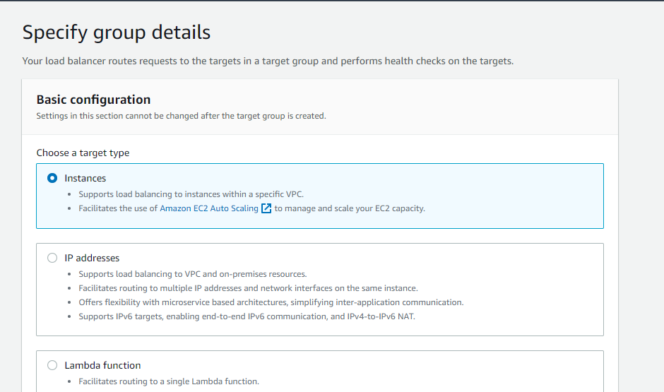

**Step-11:**Select the name of the target group.

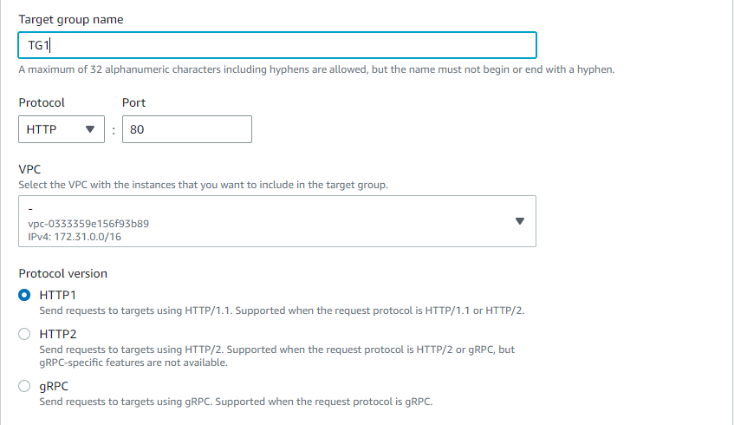

**Step-12:** Now select the instances that you want to group and click on include as pending below.

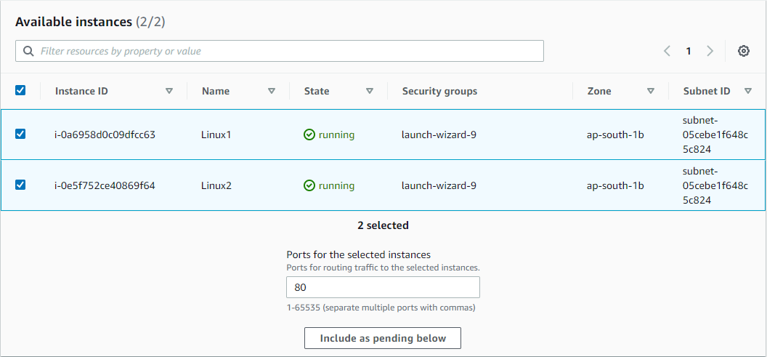

**Step-13:** The target group has been successfully created.

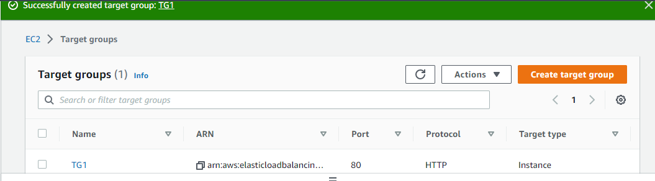

**Step-14:** Now go to instances and open the pubic IP address of both the instances in the browser.

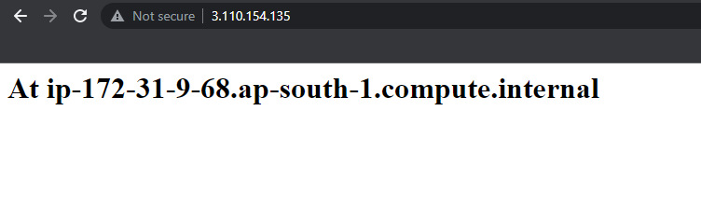

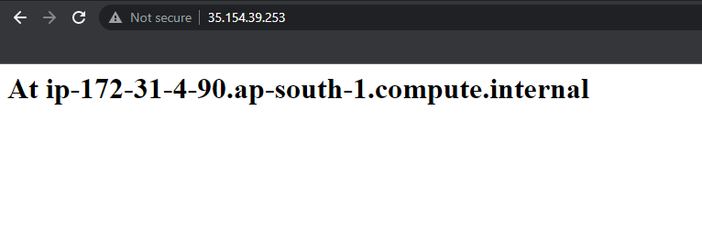

**Step-15:** Now we will create load balancer. Go to load balancing and click on load balancer. Now click on create load balancer.

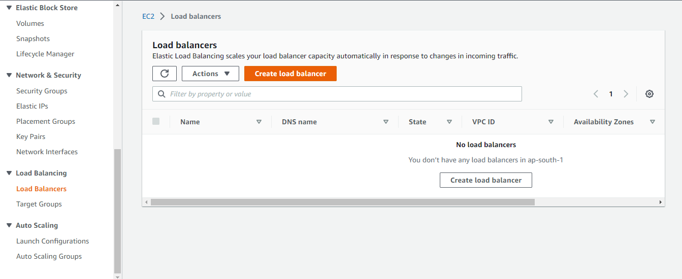

**Step-16:** Select the load balancer type and proceed.

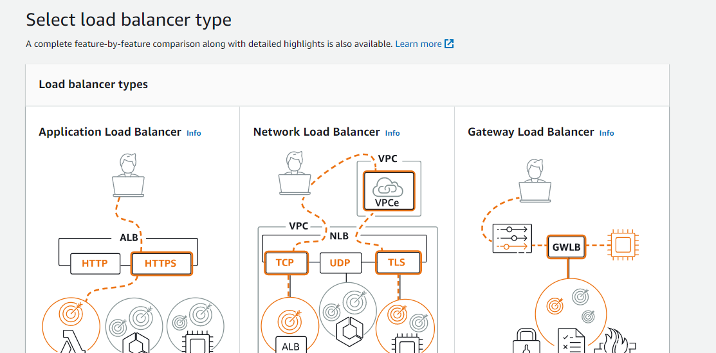

**Step-17:** Name the load balancer and select the scheme and IP address type.

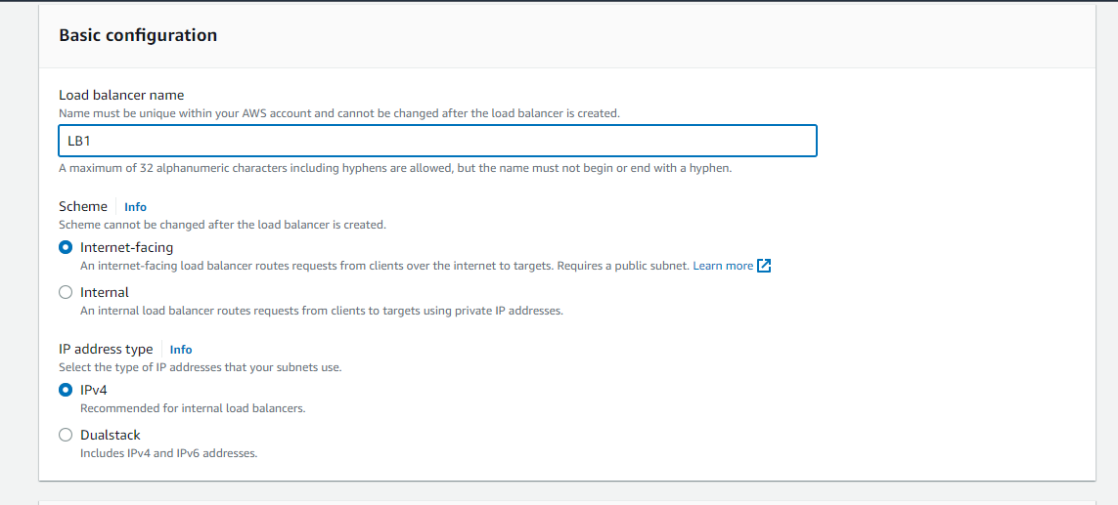

**Step-18:** Select the availability zones, preferably the one that is given in the instances.

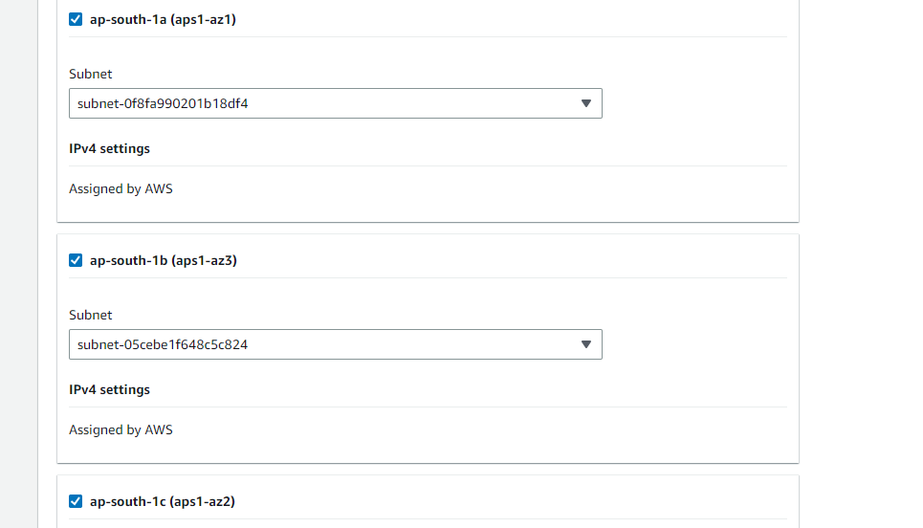

**Step-19:** Select the security group and the target group.

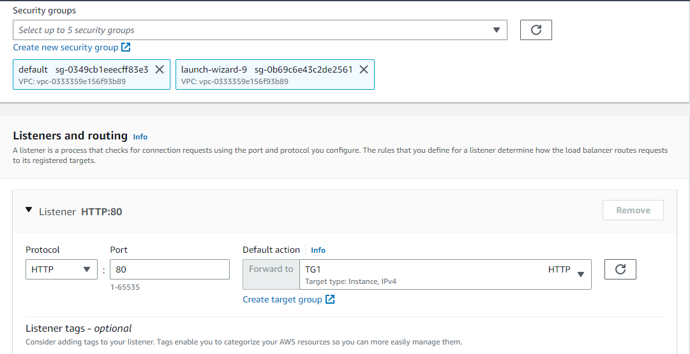

**Step-20:** Load balancer has been successfully created. Now copy its DNS and open it in browser.

